CUSTOMER_SHOPPING_BEHAVIOR
SQL QUERIES
1. What is the total revenue generated by male vs female?
Select gender,sum(purchase_amount)
From customer
group by gender;
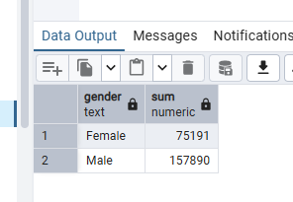
2. Which customers used a discount but still spent more than the average purchase amount?
Select customer_id,purchase_amount
From customer
Where discount_applied='Yes' And purchase_amount>=(select AVG(purchase_amount) From customer);
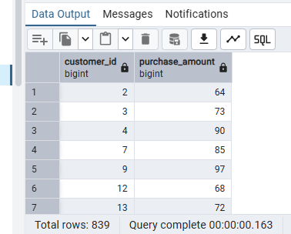
3. Which are the top 5 products with the highest Average Review Rating?
Select item_purchased, ROUND(AVG(review_rating::numeric),2) AS Average_product_rating
From customer
group by item_purchased
order by avg(review_rating)desc
Limit 5;
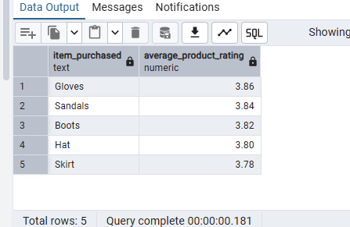
4. Compare the average purchase amounts between standard and express shipping
Select shipping_type,ROUND(AVG(purchase_amount),2)
from customer
where shipping_type In ('Standard','Express')
group by shipping_type;
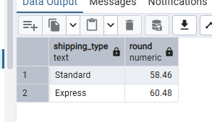
5. Do subscribes customers spend more? Compare average spend and total revenue between subscribers and non subscribers.
Select subscription_status,COUNT(customer_id),sum(purchase_amount) AS total_revenue,
ROUND(Avg(purchase_amount),2) AS average_spend
from customer
where subscription_status In ('Yes','No')
group by subscription_status;
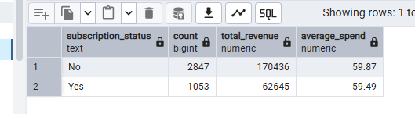
6. Which top 5 products have the highest percentage of purchases with discounts applied?
Select item_purchased,
ROUND(100*sum(CASE WHEN discount_applied='Yes' THEN 1 ELSE 0 END)/COUNT(*),2) AS discount_rate
From customer
group by item_purchased
Order by discount_rate desc
Limit 5;
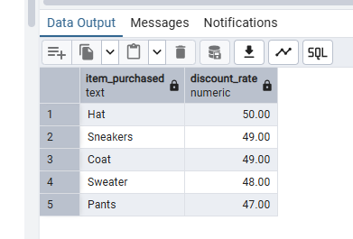
7. Segment customers into new,returning and loyal based on their total number of previous purchases and then show the count of each segment.
WITH customer_type as (select customer_id,previous_purchases,
CASE
WHEN previous_purchases=1 THEN 'New'
WHEN previous_purchases BETWEEN 2 AND 10 THEN 'Returning'
ELSE'loyal'
END AS customer_segment
from customer)
Select customer_segment, count(*) AS Number_of_Customers
From customer_type
group by customer_segment;
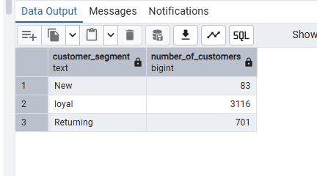
8. What are the top 3 most purchased products within each category?
With item_counts as (select category,item_purchased,COUNT(customer_id) as total_orders,
ROW_NUMBER() Over (partition by category order by Count(customer_id) desc) as item_rank
From customer
group by category,item_purchased)

Select item_rank,category,item_purchased,total_orders
From item_counts
Where item_rank <=3;
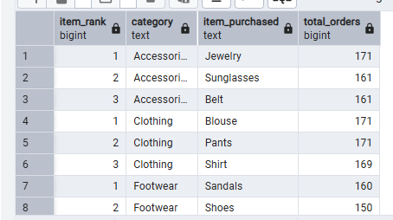
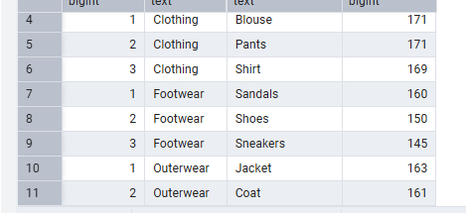
9. Are customers who are repeat buyers (more than 5 previous purchases) also likely to subscribe?
Select subscription_status,Count(customer_id) as repeat_buyers
from customer
Where previous_purchases>5
group by subscription_status;
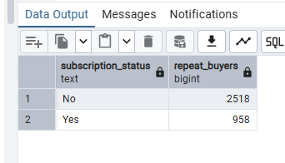
10. What is the revenue contribution of each age_group?
Select age_group, sum(purchase_amount) as total_revenue
From customer
group by age_group
Order by total_revenue desc;
